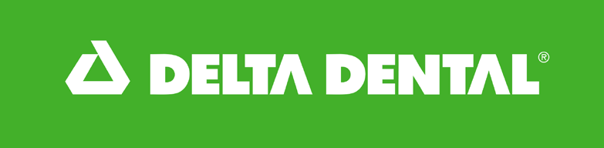

Delta Dental of South Dakota’s

Mobile Program

The Delta Dental Mobile Program provides oral health services to children who don’t have access to dental care. The program includes a mobile dental clinic truck that travels the state and dental hygienists and community health workers based on some of the state’s Native American reservations.

The Mobile Program serves approximately 2,400 kids across South Dakota every year. Care provided through the Mobile Program is at no cost to the child or family.

Mobile Clinic Truck

The Mobile Program began in 2004, and its dental clinic trucks have visited 91 communities across South Dakota, treating nearly 58,000 patients with $36.5 million in dental care.

The current truck began servicing patients in 2017. The truck is 40 feet long with two dental operatories to treat children with preventive, diagnostic and restorative care.

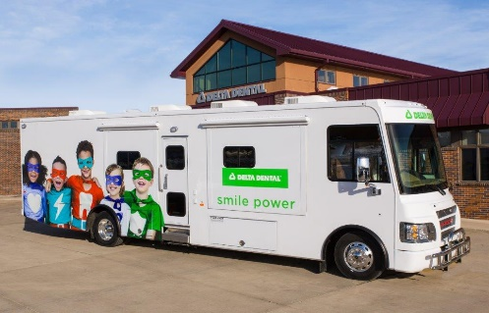Delta Dental of South Dakota (DDSD) manages, operates and staffs the truck. Local community agencies act as site partners to host a truck visit, providing the location, promoting the clinic, and recruiting and registering patients.

The truck travels with a dentist, hygienist, 2 dental assistants and a coordinator.

It costs approximately $25,000 per week to operate the truck. Local sponsors contribute a modest stipend, generally $3,000 per week, for the clinic visit.

Children through age 21 who have not seen a dentist within the past two years or who live more than 85 miles from a dentist are eligible for care.

The mobile clinic truck serves a total of approximately 1,400 kids every year and the truck staff travel across South Dakota an average of 42 weeks a year.

Mobile Program Brief Updated: 7/01/25 Page 1 of 2

A typical week for the truck includes:

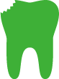  

Percent of kids treated who have tooth decay



Average number of kids treated each week

35

# 55%

Average value of care provided to each child

# $907

Average total value of dental care each week

# $31,292

Community-based care on Native American Reservations

The Mobile Program also includes dental hygienists and community health workers in communities on South Dakota’s Native American Reservations who provide oral health education, preventive care clinics, and support to access urgent dental care.

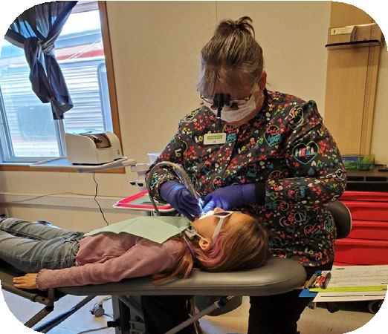This facet of the Mobile Program began in 2013 and has provided $8 million in preventive care to 16,000 kids.

Mobile Program staff work with local schools and Head Start programs to host preventive care clinics for kids in grades

K-8. Staff use portable equipment in a spare room at each location to provide oral health screenings, cleanings, fluoride varnish treatments, and dental sealants.

Mobile Program staff serve roughly 1,000 kids each year. Since the program began, care has included:

 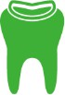 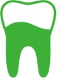

Total patient visits

# 38,157

Total sealants placed

# 69,942

Total fluoride varnish treatments

# 37,801



For more information about Delta Dental’s community activities, visit <https://southdakota.deltadental.com/mission/> or contact Zach Parsons, Program Manager, at 605-224-7345 or [zach.parsons@deltadentalsd.com](mailto:zach.parsons@deltadentalsd.com)

Mobile Program Brief Updated: 7/02/25

Page 2 of 2